Target Audience
Emergency Skills & Cognitive Aids for Neuro-anaesthesia (eSCAN Course)
New for 2021
Advanced trainees, provisional fellows and consultant anaesthetists
Experienced anaesthetic nurses/ technicians. (Anaesthetists are encouraged to attend with a nurse from their place of work)
CPD
The course is a recognised emergency response activity in ANZCA’s CPD program:-
- Cardiac Arrest
The course also provides 16 CPD points (8 hours) in the “Knowledge & Skills/Short Courses” category
Description
Aims
This course aims to update the participants knowledge of, and ability to, manage a variety of emergencies in neuro-anaesthesia while simultaneously developing general crisis management skills applicable to emergency situations across all areas of anaesthetic practice. Skills and knowledge essential for the safe delivery of neuro-anaesthesia will also be addressed.

Instructors
The course will be facilitated by a combination of experienced paediatric anaesthetists and instructors with expertise in simulation and crisis management

Topics covered:-
- Advanced life support in the context of the neurosurgical patient
- Management of raised intra-cranial pressure and the unstable C-spine
- Recognition and initial management of a range of intraoperative neuro-anaesthetic crises
- Human factors and cognitive aids to prevent and manage these events

Training Methods
(See our website: Training/Before Training)
- Immersive scenarios with reflective debriefing
- Hands-on Skills Workshops
- Pause & discuss scenarios
- Video and case-based learning exercises
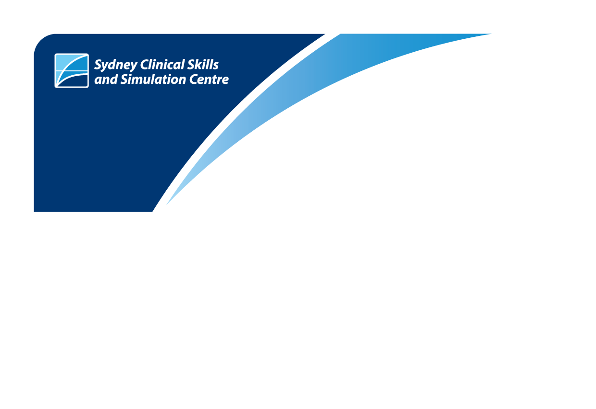
Maximum Participants
Maximum 12 participants per course.
Course Duration
1 day course (0800 – 1700 hours)
Course Dates 2021
27th July
Cost
Anaesthesia

$1430 (Incl. GST) per anaesthetist
$715 (Incl GST) per trainee
$330 (Excluding GST) per anaesthetic nurse/technician
Free of charge RNSH anaesthetic nurses
Course Co-ordinator
Dr Adam Rehak MBBS FANZCA
Instructors: See our website: About SCSSC/About us/Our Team
Provider | 

Level 6, Kolling Building
Royal North Shore Hospital
St Leonards NSW 2065
Enquiries
NSLHD-SMSC@health.nsw.gov.au
Ph: (02) 9926 4646
Fax: (02) 9926 6755

